TEST PLAN FOR

<<TRUECHECK COUNTERFEITING DETECTION SYSTEM>>

*ChangeLog*

| **Version** | **Change Date** | **By** | **Description** |
| --- | --- | --- | --- |
| 001 | 30.10.23 | Archit Rajesh Srivastava, Bhoomika Saxena | Initial Draft |
|  |  |  |  |
|  |  |  |  |

**1** **INTRODUCTION 2**

1.1 Scope 2

*1.1.1* *In Scope 2*

*1.1.2* *Out of Scope 2*

1.2 Quality Objective 2

1.3 Roles and Responsibilities 2

**2** **TEST METHODOLOGY 3**

2.1 Overview 3

2.2 Test Level……………………………………………………………………………………………………………………………………..3

2.3 Test Completeness 4

**3** **TEST DELIVERABLES 4**

**4** **RESOURCE & ENVIRONMENT NEEDS 4**

4.1 Testing Tools 4

4.2 Test Environment 4

**5** **TERMS/ACRONYMS 5**

# **Introduction**

Counterfeiting is a severe economic and social issue, affecting both industries and the global market. The illicit trade in counterfeit brands poses a significant threat to the world economy, hindering the growth of brands in India and worldwide. Fraudulent activities related to forgery and counterfeit products have surged across various industries in recent decades. This trend has left consumers struggling to differentiate genuine products from counterfeits. To combat this problem, a "Counterfeit Detection System" is proposed.

The Counterfeit Detection System is a vital web application designed to combat the pervasive issue of counterfeit clothing products. In a world where consumers often find themselves in a precarious position—uncertain whether the product they intend to purchase is genuine or a deceptive knockoff—this innovative solution emerges as a safeguard against fraud. The ramifications of unknowingly buying counterfeit goods are profound, leading to financial losses for consumers and tarnishing the reputation of authentic brands. For companies, the consequences include lost sales due to undercutting prices, erosion of brand integrity, strained relationships with business partners, and the need to allocate resources to combat counterfeiting.

Recognizing the urgency of this problem, the Counterfeit Detection System steps in to assist users in navigating this treacherous terrain. Its mission is clear: to empower consumers with the tools needed to make informed purchasing decisions and to eradicate counterfeit products from the marketplace. At its core, this web application leverages the innovative concept of QR code scanning, offering a seamless and efficient means of verifying product authenticity during the purchasing process.

## **Scope**

### In Scope

**Functional Requirement:-**

Uid Generation: The system must generate unique id that will map with the database of products and generate qr codes specific to each product.

QR Code Validation: The system shall be able to scan the qr code that helps in verification of integrity of the products.

User Interface: The system should provide a user-friendly interface for users to scan qr codes and get the verification results.

Alerts & Notifications: The system must be able to produce alerts both for users as well as administrators when a counterfeit product is detected.

Feedback: The system should be able to be customized so that users can write feedback of products about its quality.

**Non-Functional requirement:-**

Performance:

Speed: The system should perform style transfer efficiently, with minimal processing time.

Response Time: The system should provide quick response to QR scans and execute the further process with minimum delay in verification.

Scalability: It should be able to handle a number of QR scan requests without degradation of system’s performance.

Security:

Data Authentication: The system must ensure the security and encryption of data to prevent unauthorised access of third party.

Reliability:

Availability: The system must have high availability ensuring continuous operation and avoid circumstances of downtime.

### Out of Scope

Out of scope for the counterfeit detection system are integration with third party systems, supply chain management, advanced physical packaging and labeling, and targeting other industries.

## **Quality Objective**

* Ensure the Application Under Test conforms to functional and non-functional requirements.
* Ensure the AUT meets the quality specifications defined by the client.
* Bugs/issues are identified and fixed before go live.
* Ensure that the system should assess the legitimitate QR codes and flag the counterfeit products accurately.
* Prioritize a user-friendly and intuitive interface to enhance user experience, making it easy for users to use the system effectively.
* Ensure that the system functions correctly on a variety of devices, browsers, and operating systems to maximize user accessibility.

## **Roles and Responsibilities**

Detail description of the Roles and responsibilities of different team members like

* **QA Analyst**- Archit Rajesh Srivastava, Bhoomika Saxena
* **Test Manager**- Dr. Harsh Khatter
* **Configuration Manager**- Prof. Akanksha
* **Developers**- Archit Rajesh Srivastava, Bhoomika Saxena
* **Installation Team**- Archit Rajesh Srivastava, Bhoomika Saxena, Ankita Jain

# **Test Methodology**

## **Overview**

An Agile methodology is the most suitable for this project. It allows for flexibility, ongoing testing, and adaptation, which are essential for projects that involve scanning, verification, mapping with database. Agile enables you to respond to changing requirements and refine the redirection process as you gain insights from testing and user feedback.

## **Test Levels**

The testing to be performed is white box testing.

The testing is performed by the developers team along with QA and Configuration Manager.

**Unit Testing:**

Scope: Individual components and modules of counterfeit detection system are being considered.

Objective: To verify that each component works as intended, including admin side, login module, manager module, etc.

Testing Approach: Developers and testers conduct unit tests to validate the correctness of the algorithm at a granular level.

**Integration Testing:**

Scope: The interactions and interfaces between various components, modules, and frameworks used in the project.

Objective: To ensure that the integration of different components does not introduce errors or inconsistencies in the QR validation process.

Testing Approach: Developers and testers assess the data flow and interactions between components and modules and detect any integration issues.

**Functional Testing:**

Scope: The complete counterfeit detection system.

Objective: To validate that the system functions according to specified requirements and that it performs accurate procedure.

Testing Approach: Testers execute functional tests by providing QR codes and verifying that the output determines which product is counterfeited or not.

**Performance Testing:**

Scope: Assessing the system's speed and efficiency in handling multiple scanning requests at the same time.

Objective: To measure how well the system performs in terms of processing time, memory utilization, and resource consumption.

Testing Approach: Performance tests evaluate the system's response time and resource usage under various loads and conditions.

**Usability Testing:**

Scope: The user interface and user experience.

Objective: To assess how user-friendly and intuitive the interface is for users to scan the qr code, redirect to the company’s database and give details about the product.

Testing Approach: Usability tests involve users interacting with the system to evaluate the ease of use, clarity, and navigation of the interface.

**Security Testing:**

Scope: The system's security mechanisms, especially for handling bulky data.

Objective: To identify and mitigate potential security vulnerabilities, including data breaches and unauthorized access of third party.

Testing Approach: Security testing includes penetration testing, data encryption checks, and access control assessments.

**Compatibility Testing:**

Scope: The system's compatibility with various platforms and devices.

Objective: To ensure that the system functions correctly on different browsers, operating systems, and devices.

Testing Approach: Testers verify that the system is compatible with a range of devices and configurations.

**Regression Testing:**

Scope: The entire system after updates or changes.

Objective: To confirm that new changes or enhancements do not introduce defects or negatively impact existing functionality.

Testing Approach: Automated regression tests are executed to validate that previously tested features still work as expected.

## **Test Completeness**

Here you define the criterias that will deem your testing complete.

For instance, a few criteria to check Test Completeness would be

* 100% test coverage.
* All Manual & Automated Test cases executed.
* All open bugs are fixed or will be fixed in next release.
* All scanning, verification, redirection, alert generation have been processed successfully.
* Automated regression tests have been executed, and previously tested features still work as expected after updates or changes.

# **Test Deliverables**

# **Test cases:-**

| **Test Case** | **Test Objective** | **Test Data** | **Expected Result** |  | **Actual Result** | **Pass/Fail** |
| --- | --- | --- | --- | --- | --- | --- |
| 1 | User Login | User Id and Password | Only Valid User login in the system |  | Unauthorized  User can  not login | Pass |
| 1 | Uid Generation | Mapping of uid with database | Uid should be accurately mapped with database of company |  | Unique Id generated | Pass |
| 2 | QR Code Generation | Uid associated with product generate QR | QR code should be generated |  | Scanable QR Code generated | Pass |
| 3 | QR Code Scanning | Scanning of qr code is done | QR Code should be scanned properly |  | QR code recognizable | Pass |
| 4 | Redirection to the company’s site | QR Code validation | Generated QR code should be valid |  | Valid QR, redirected to company’s site | Pass |
| 5 | Alert Generation | Verification of QR Code | If the product is counterfeited, alert is generated |  | Fake Product, hence generates alert | Pass |
| 6 | User Interface of company’s site | Validation of Company’s data | UI should have user friendly experience |  | All necessary details of the product are visible to users | Pass |
| 7 | Updation of status of product | Company’s Database | It should automatically update the status of product as sold after selling to consumer |  | Automatically status updated | Pass |
| 8 | Verify data security | Testing with simulated security breaches | No unauthorized access or data breaches detected |  | Unauthorized  User can  not access | Pass |
| 9 | Assess the impact of updates | System before and after updates | Previously tested features still work as expected |  | Previously tested features work accurately | Pass |
| 10 | User Feedback for the product | User Interface of the system | User should be able to write feedback of the product to the company’s site |  | User drops reviews about the product | Pass |

**Decision Table for User Login**

| **Conditions** | **Rule 1** | **Rule 2** | **Rule 3** | **Rule 4** |
| --- | --- | --- | --- | --- |
| Username | False | True | False | True |
| Password | False | False | True | True |
| Output(e/h) | error | error | error | homepage |

**Decision Table for QR Validation**

| **Conditions** | **Rule 1** | **Rule 2** | **Rule 3** | **Rule 4** |
| --- | --- | --- | --- | --- |
| QR valid | False | True | False | True |
| QR Invalid | False | False | True | True |
| Output | error | Original Product | Counterfeited Product | error |

**Test case Output Images**

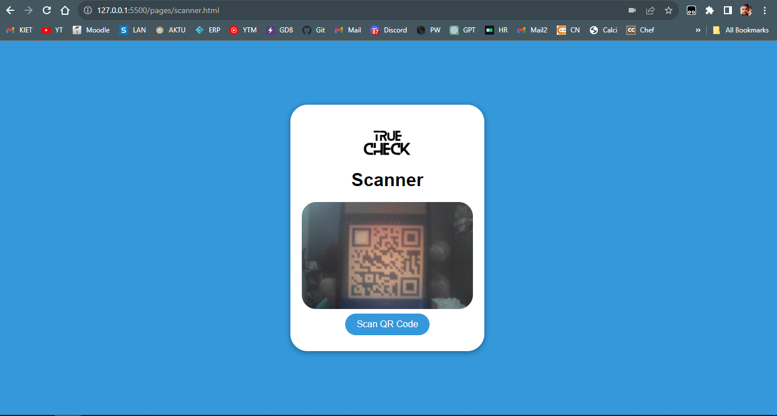   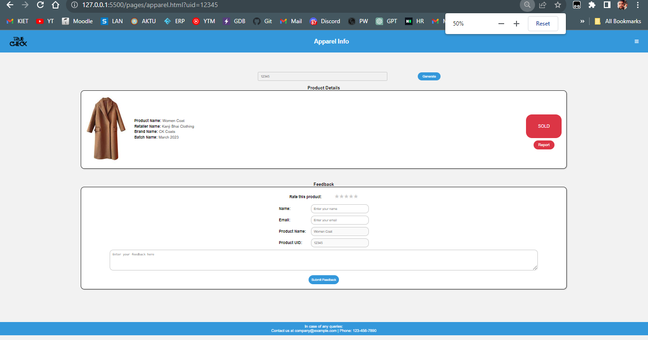

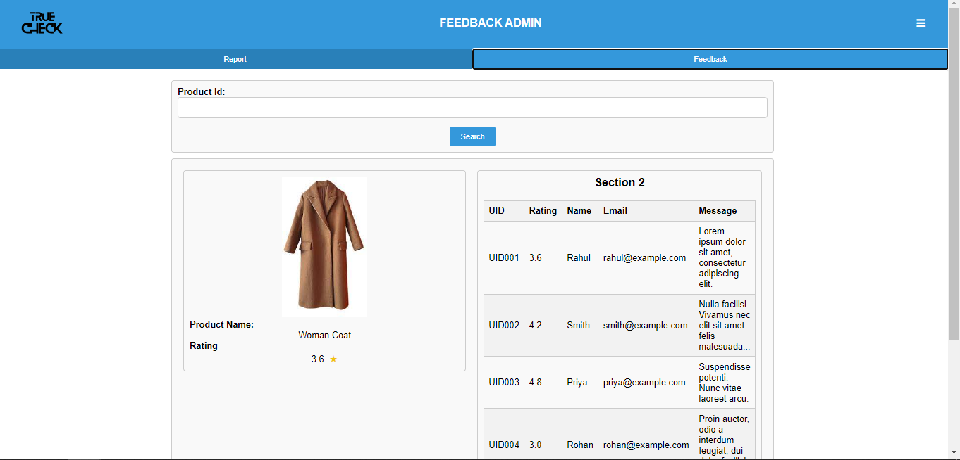

# **Resource & Environment Needs**

## **Testing Tools**

**1. Requirements Tracking Tool:**

JIRA: JIRA is a versatile tool for tracking requirements, user stories, and project tasks. It can help manage and prioritize project requirements effectively.

**2. Bug Tracking Tool:**

BUGZILLA: Bugzilla is an open-source bug tracking tool that allows teams to efficiently track and manage software defects and issues.

**3. Automation Tools:**

SELENIUM: Selenium provides framework to automate testing of web application that uses QR code for counterfeit detection.

## **Test Environment**

It mentions the minimum **hardware** requirements that will be used to test the Application.

Following **software’s** are required in addition to client-specific software.

* Windows 8 and above
* Office 2013 and above
* MS Exchange, etc.

# **Terms/Acronyms**

Make a mention of any terms or acronyms used in the project

| **TERM/ACRONYM** | **DEFINITION** |
| --- | --- |
| API | Application Program Interface |
| AUT | Application Under Test |